System Modelling for MAEs

# Introduction

Magnetoactive elastomers (MAEs) belong to a class of soft active materials that respond to remotely applied magnetic field. The application of magnetic field results in the modification of mechanical behaviour and deformation (also referred to as magnetostriction) of these active materials. Thanks to their simple, remote, and reversible principle of operation,

MAEs can provide the material platform for applications such as

1. variable-stiffness devices
2. tuneable vibration absorbers,
3. damping devices,
4. sensors,
5. noise barriers,
6. remotely controlled actuators,
7. biomedicine
8. soft robotics among many others.

In principle, MAEs are composite materials consisting of magnetizable particles (for example, carbonyl iron, nickel, or Terfenol-D) embedded in an elastomeric matrix material (such as silicone rubber, polyurethane). The magnetizable particles (from micro- to nano-size) are added into the matrix material in its liquid state. Upon polymerization, the MAEs with randomly distributed magnetizable particles are produced. Curing in the presence of a magnetic field, however, results in the alignment of magnetizable particles into chain-like structures (for a detailed description of the MAE synthesis.

While the heterogeneity provides access to the tailored and enhanced coupled behaviour, it is also a source for the development of microstructural instabilities. **The instability phenomenon historically has been considered as a failure mode,** which is to be predicted and avoided.

The free and forced vibration response for MAEs and spring systems were compared.

# Free vibrations

The behaviour of an MAE was studied under free oscillations. The system was allowed to oscillate freely. This was compared to a simscape model system. The damping was removed for clarity.

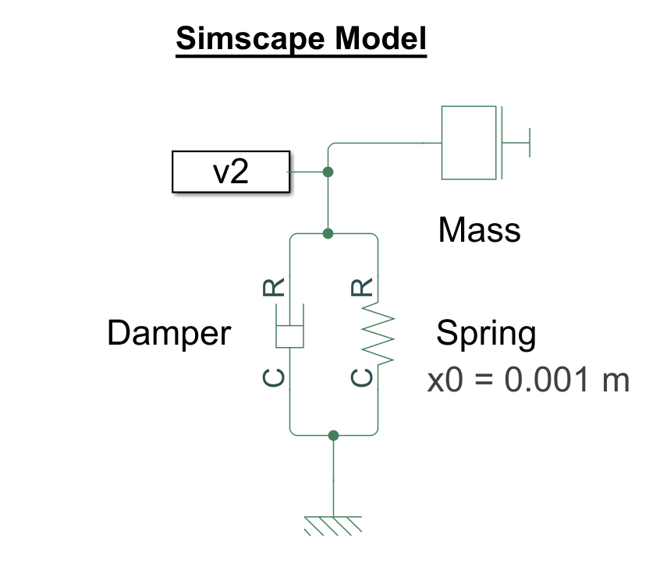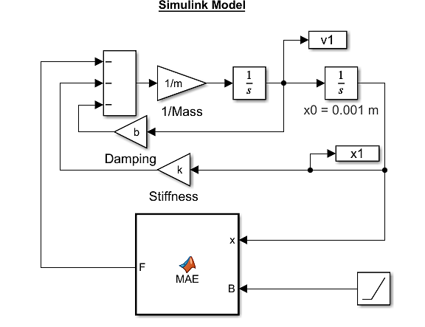

The following parameter values were used for Shear modulus & volume fraction

$$\frac{G_{2}}{G_{1}}=\frac{μ_{2}}{μ_{1}}=10$$

$$c_{2}=0.1,c_{1}=0.9$$

$$σ_{11}=\frac{F}{A},σ_{22}=0,$$

$$G_{1}=50 kPa,μ_{0}=4π{10}^{-7}$$

Where bar and cap averaging imply linear and harmonic mean respectively (with respect to volume fraction.)

$$\overline{ϕ}=ϕ_{1}c_{1}+ϕ_{2}c_{2}$$

$$\hat{ϕ}={\left(\frac{c_{1}}{ϕ_{1}}+\frac{c_{2}}{ϕ_{2}}\right)}^{-1}$$

The traction force on the MAE was given by

The magnetic stability limit is given by

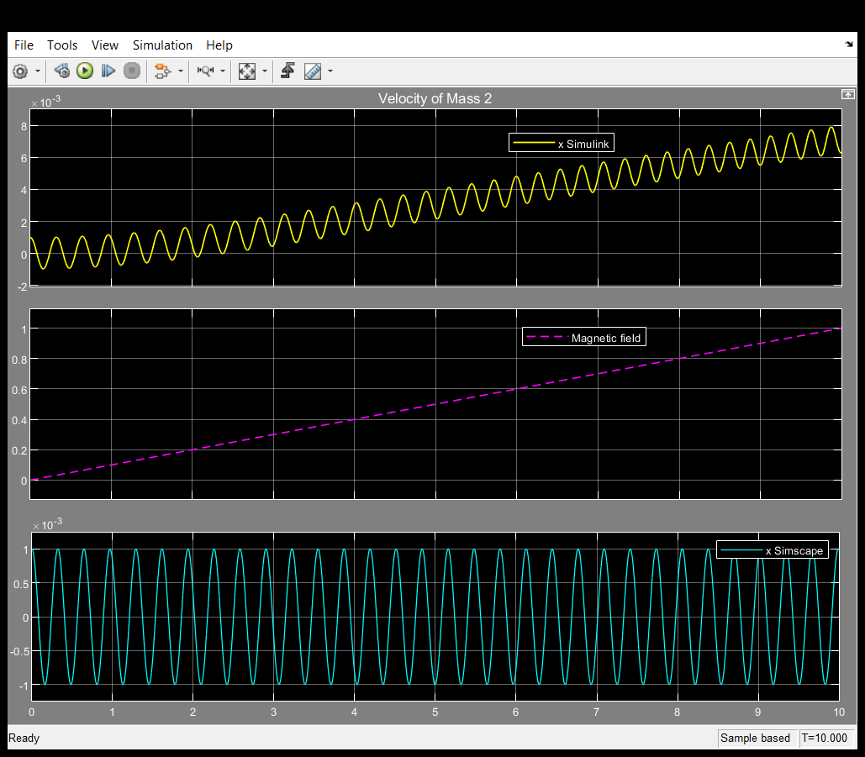

The equilibrium point and the natural frequency were tuned by using the magnetic field.

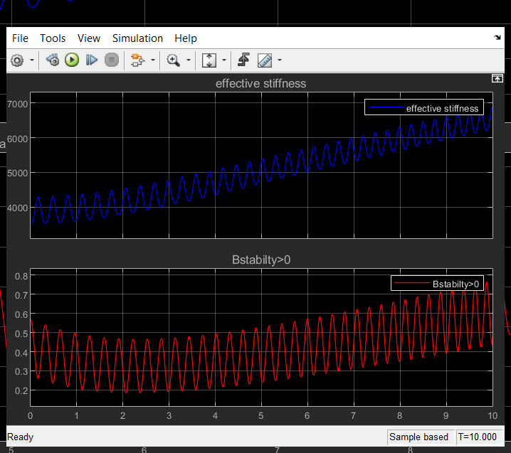

The effective stiffness was tuned from 4000 to 7000.



# Forced vibrations

A sinusoidal input signal is applied to cause forced vibrations to an oscillating system.

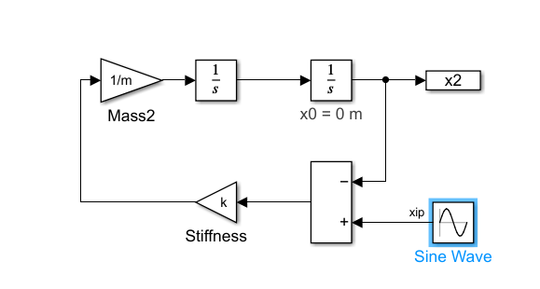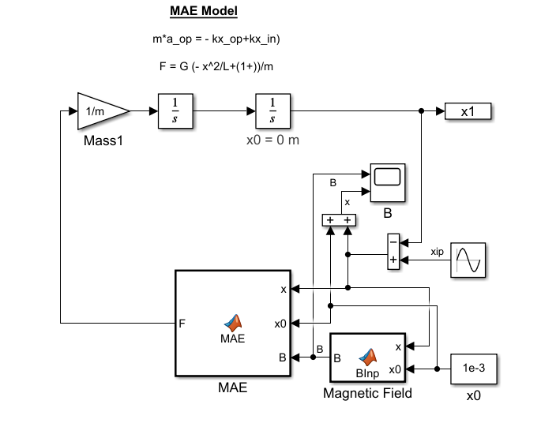

As compared to the spring, the MAE can completely block the input signal from transmitting towards the output.

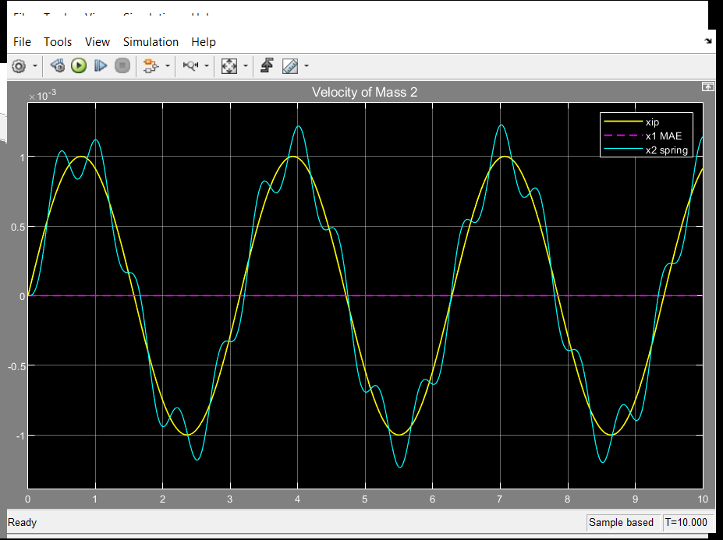

The MAE remains in the stable region.

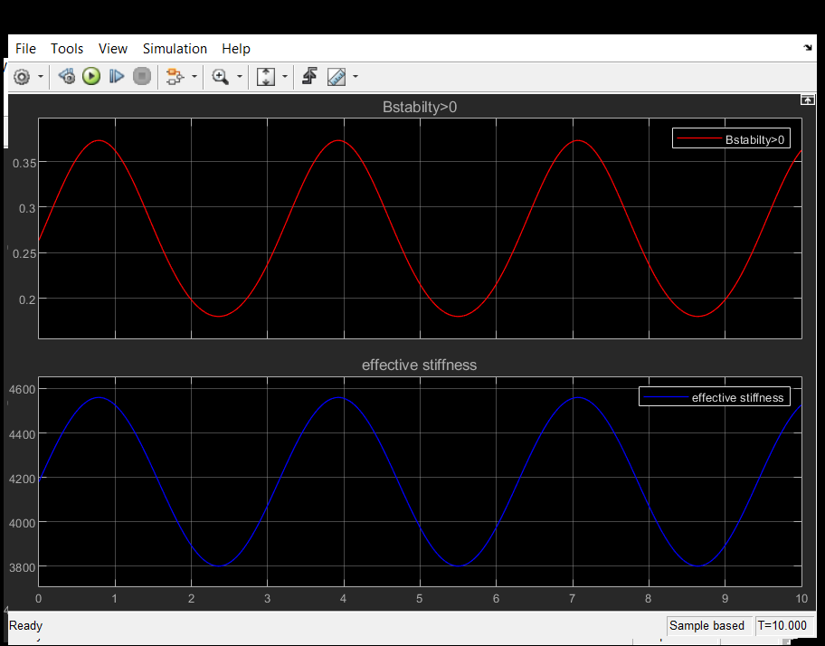

# Conclusion

1. The MAEs could be tuned to remove noise and isolate the output from the input.
2. The equilibrium point can be adjusted by applying a magnetic field.
3. The only limitations are saturation and the stability limits for MAEs which need to be tuned for the desired output range.

# References

1. Pathak, P., Arora, N., & Rudykh, S. (2022). Magnetoelastic instabilities in soft laminates with ferromagnetic hyper elastic phases. International Journal of Mechanical Sciences, 213, 106862.
2. Rudykh, S., & Bertoldi, K. (2013). “*Stability of anisotropic magnetorheological elastomers in finite deformations: a micromechanical approach”*. Journal of the Mechanics and Physics of Solids, 61(4), 949-967.
3. Galich, P. I., & Rudykh, S. (2016). Manipulating pressure and shear waves in dielectric elastomers via external electric stimuli. International Journal of Solids and Structures, 91, 18-25.
4. Bertoldi, K., & Gei, M. (2011). Instabilities in multilayered soft dielectrics. Journal of the Mechanics and Physics of Solids, 59(1), 18-42.
5. Rudykh, S., & Debotton, G. (2011). Stability of anisotropic electroactive polymers with application to layered media. Zeitschrift für angewandte Mathematik und Physik, 62(6), 1131-1142.
6. Galipeau, E. (2012). Non-linear homogenization of magnetorheological elastomers at finite strain.
7. Rudykh, S., Bhattacharya, K., & DeBotton, G. (2014). Multiscale instabilities in soft heterogeneous dielectric elastomers. Proceedings of the Royal Society A: Mathematical, Physical and Engineering Sciences, 470(2162), 20130618.
8. Goshkoderia, A., & Rudykh, S. (2017). Stability of magneto-active composites with periodic microstructures undergoing finite strains in the presence of a magnetic field. Composites Part B: Engineering, 128, 19-29.